|  |  |  |  |  |
| --- | --- | --- | --- | --- |
| **National University of Computer and Emerging Sciences, Lahore Campus** | | | | |
| C:\Users\saif\AppData\Local\Microsoft\Windows\Temporary Internet Files\Content.Word\final design.jpg | **Course:** | **Object Oriented Programming** | **Course Code:** | **CS-1004** |
| **Program:** | **BS (CS,SE,R,DS)** | **Semester:** | **Fall 2023** |
| **Paper Date:** | **20-Feb-24** | **Total Marks:** | **10** |
| **Section:** | **BSSE-4A** | **Duration:** | **10 Minutes** |
| **Exam:** | **Quiz 2** | **Roll No.** |  |
| **Instruction/Notes:** | Attempt all questions. Do not use pencil or red ink. In case of confusion or ambiguity make a reasonable assumption. Do not attach any extra sheet. Use extra sheet for rough work only | | | |

Question 1:

1. Create a table **Patient** with following fields

* PatientID integer (4)
* Name varchar (15)
* Age int
* Gender varchar(5)
* Address varchar(20)
* Disease varchar(10)
* DoctorID varchar(15)

**Constraints.**

* **PatientID**in Patient, is primary key. PatientID should start from 1000

1. Change the datatype of Gender from varchar(5) to char in **Patient** table.

**Question 2.**

**Tbl_Sailor Tbl_Reserve Tbl_Boats**

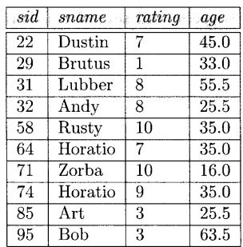 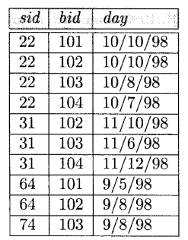 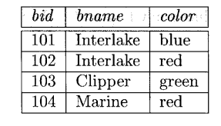

Show the Sailor names who have age greater than 33 and has boats whose color is ‘red’ in ascending order.

Delete the Sailor named ‘Horatio’

Update day to current date where sid=64 and day=’9/8/98’